Practical No: 7

Aim: Study and implement Cloud Security management with Two-Factor Authentication in aws.

Part 1: Implementation of MFA in AWS
Secure an AWS IAM User account by enforcing Virtual MFA using a smartphone app.

Phase 1: Prerequisites
- AWS Account: You need access to an AWS Account (logging in as the Root user or an Administrator).
- Authenticator App: Download and install an authenticator app on your smartphone (Android or iOS).
- Common free options include:
  - Google Authenticator
  - Microsoft Authenticator
  - Authy

Phase 2: Enable MFA in the AWS Console
1. Log in to AWS:
  - Open your browser and log into the AWS Management Console.
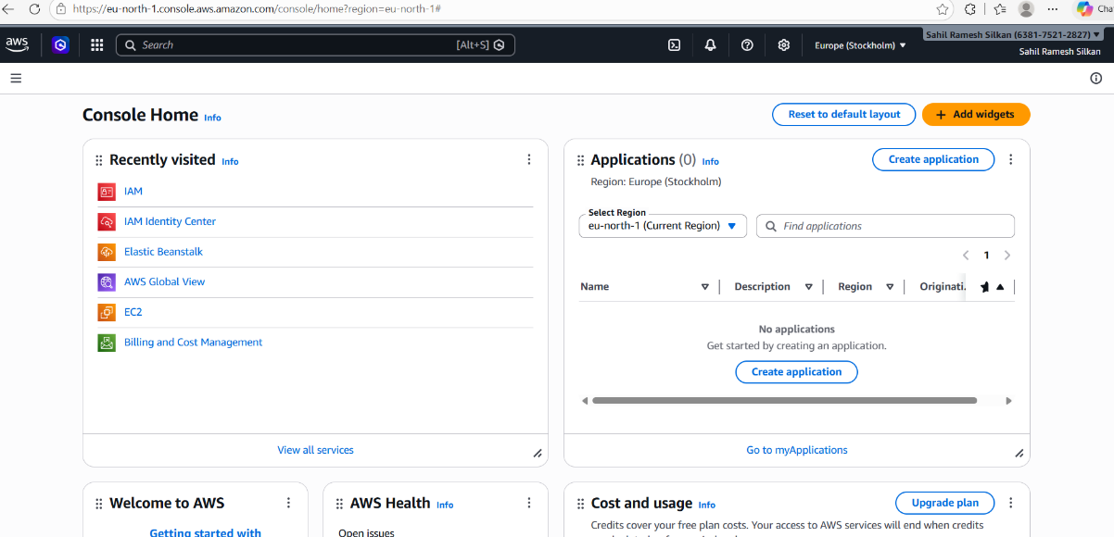
- Navigate to IAM:
  - In the top search bar, type IAM and click on the IAM (Identity and Access Management) service.
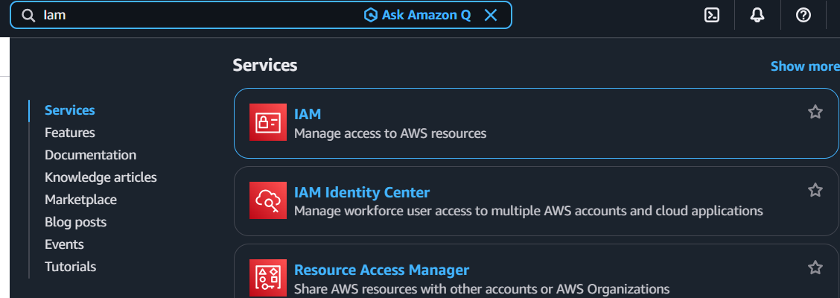
- Select a User:
  - On the left-hand navigation pane, click on Users.
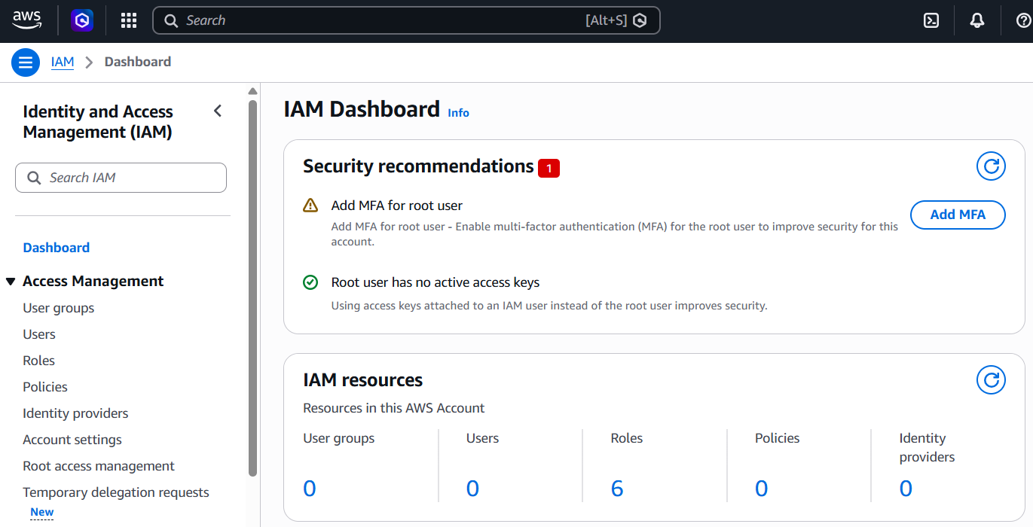

  - Click on the name of the user you want to secure. (Note: If you are using the Root account, click on your account name at the top right of the navigation bar and select "Security credentials").
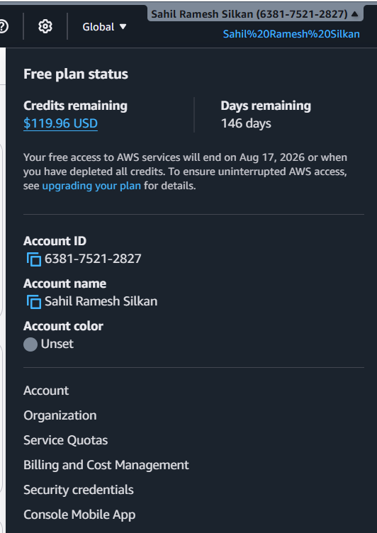
- Assign MFA Device:
  - Click on the Security credentials tab for that user.
  - Scroll down to the Multi-factor authentication (MFA) section.
  - Click the Assign MFA device button.
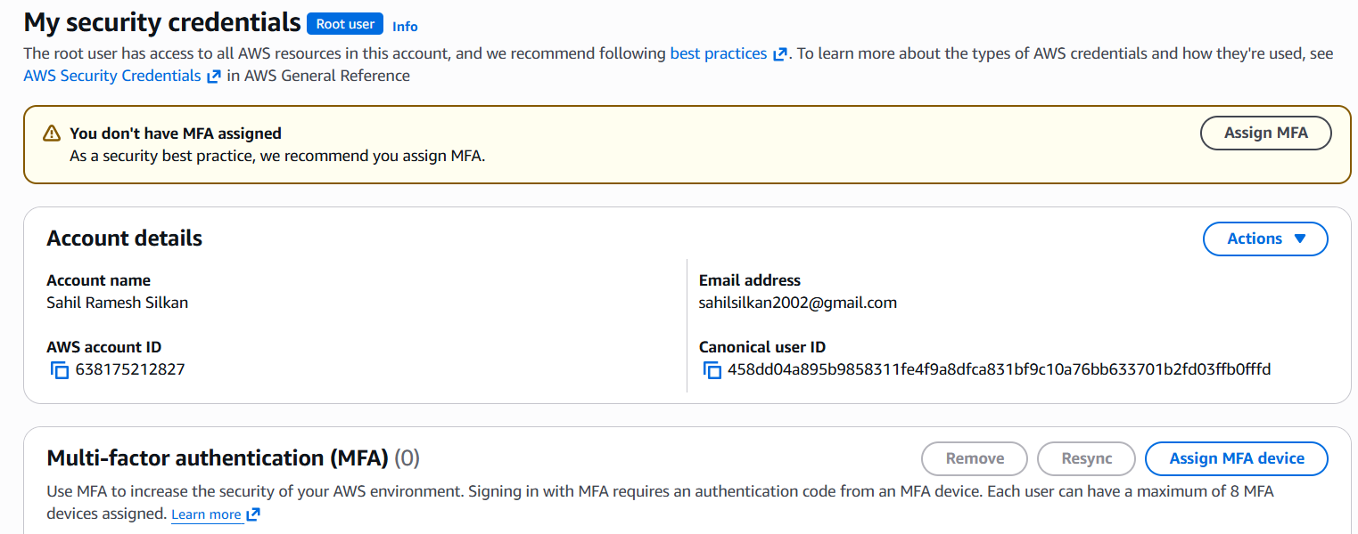
- Configure the Device:
  - Device Name: Give it a recognizable name (e.g., MyPhone).
  - MFA device type: Select Authenticator app (Virtual MFA device).
  - Click Next.
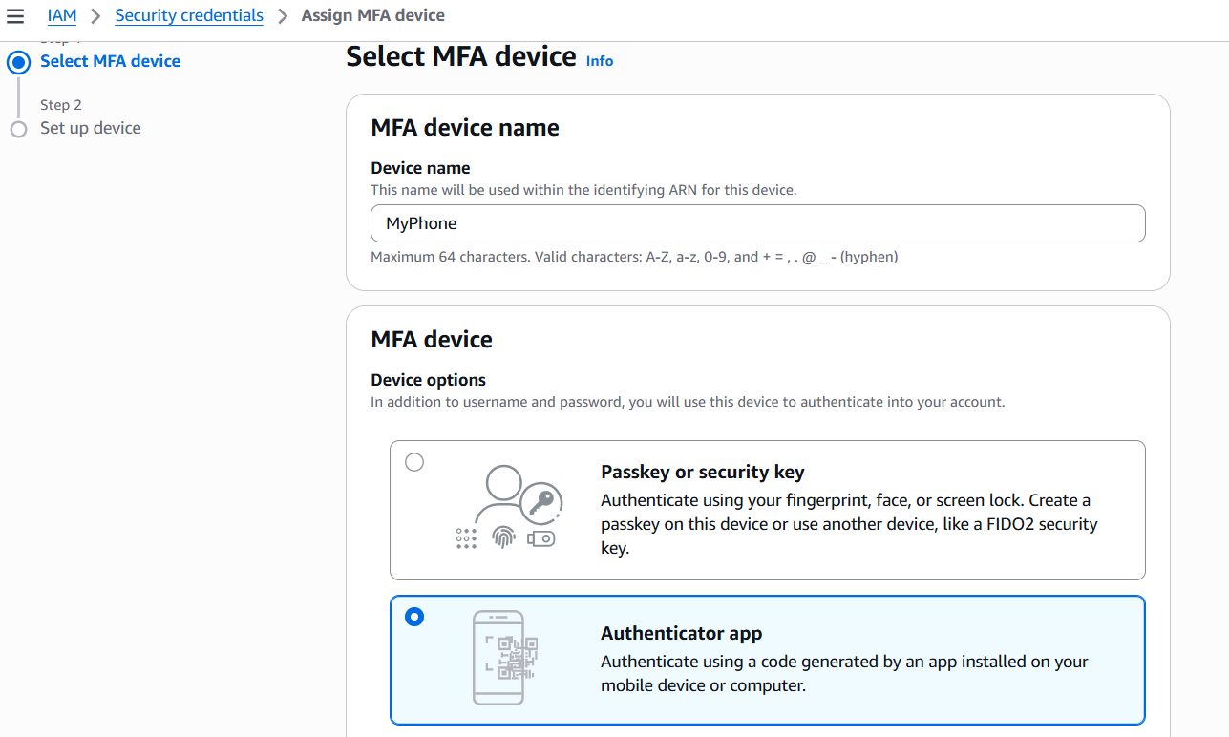

- Sync the App with AWS:
  - Click the link to Show QR code.
  - Open the Authenticator app on your smartphone and select the option to add a new account by scanning a QR code.
  - Point your phone's camera at the QR code on your Windows 11 screen. The app will now generate a rolling 6-digit code for AWS.
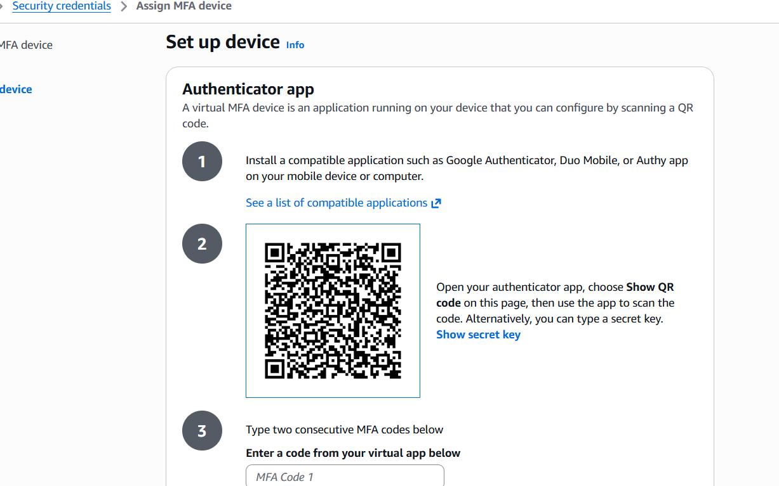
- Verify the Codes:
  - AWS requires two consecutive codes to ensure synchronization.
  - Look at your phone, type the current 6-digit code into the MFA code 1 box.
  - Wait about 30 seconds for the code on your phone to change.
  - Type the new 6-digit code into the MFA code 2 box.
  - Click Add MFA.

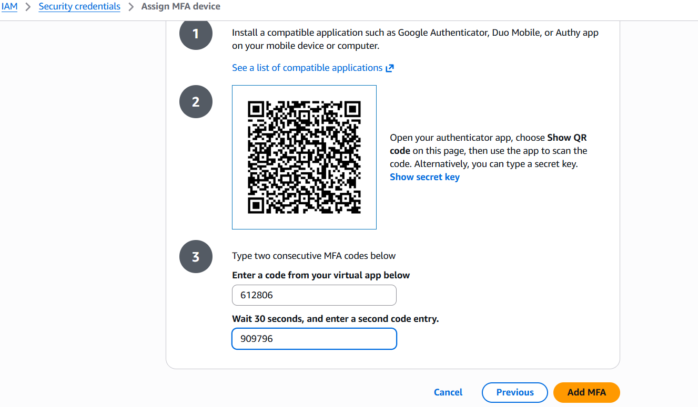
Result: You should see a green success banner stating that the virtual MFA device has been successfully assigned.
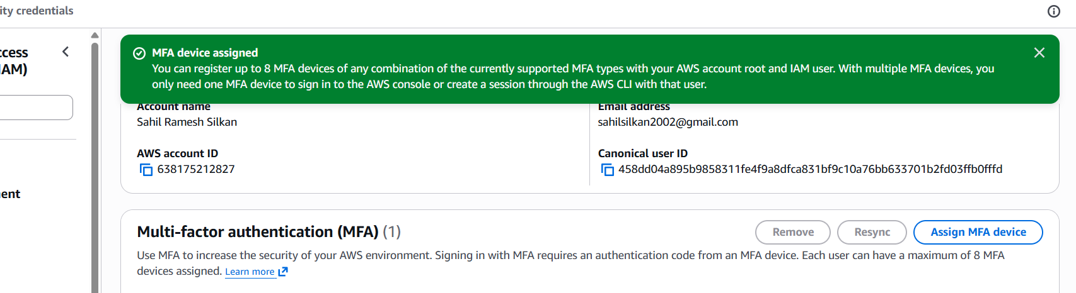

Phase 3: Test the Security Implementation
- Sign out of the AWS Management Console completely.
- Attempt to sign back in using the username and password for the account you just secured.
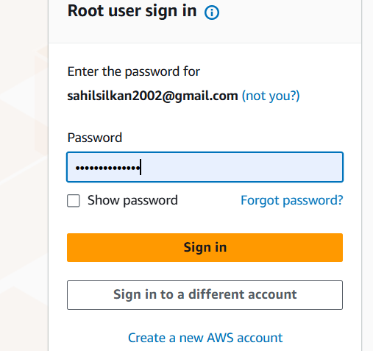
- The MFA Prompt: After entering the password, AWS will block access and redirect you to a new screen asking for an MFA code.
- Open the Authenticator app on your phone, read the current 6-digit code, and enter it into the AWS prompt.
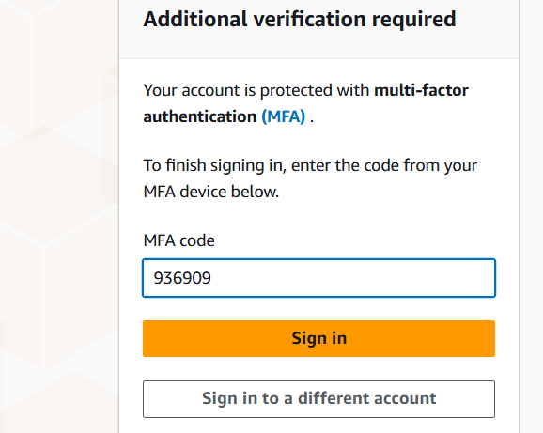
- Click Submit. You will now be granted access to the cloud environment.
